**Assignment 1**

Name & Roll no:

Mudasra 17581556-084

Section:

Bs-IT-(B)

Submitted to:

Sir Nauman

Course Code:

IT-423

Course Title:

# System Integration and Architecture

Submission Date:

05-04-2021



**Problem:**

Weather Forecasting

**Solution:**

Given dataset:

No. of Attributes: 4

Names of Attributes:

1. Temperature
2. Month
3. Year
4. Rain

**Code:**

Step i:

Importing libraries to read data and process it.

import numpy as np

import pandas as pd

import pandas_profiling

import matplotlib.pyplot as plt

import seaborn as sns

import missingno as msno

import plotly.express as px

import plotly.io as pio

%matplotlib inline

**Step ii-**

Storing dataset in a variable.

df = pd.read_csv("/Temp_and_rain.csv")

**Step iii-**

Reading data from the start.

df.head()

**Step iv-**

Defining data types of the dataset.

df.info()

**Step v-**

Defining operations performed on data and values of performed operation.

df.describe()

**Step vi-**

Checking the profile of given data set.

profile = pandas_profiling.ProfileReport(df)

profile

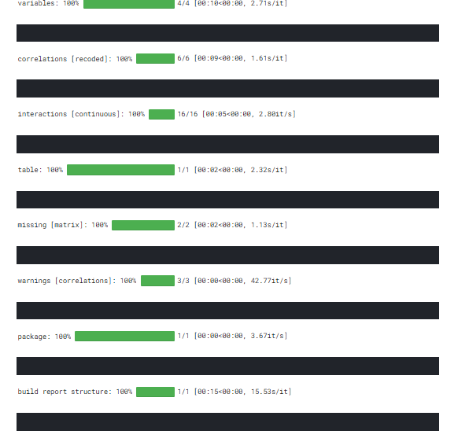

**Step vii-**

Now checking if there is null value in the data.

df.isnull().sum()

**Step viii-**

Making statical view of data using seaborn.

sns.set()

n = msno.bar(df,color="purple")

**Step ix-**

Slicing our dataset into first 50 Years,and analyze the weather of these Years. Checking the relation between years and rain.

df1 = df.loc[0:599,:]

df1.tail()

**Step x-**

Finding the amount of rain with respect to years.

Setting variables of the dataset.

sns.set()

plt.figure(figsize=(16,8))

sns.regplot(x = "Year",y="rain",fit_reg = False,data=df1)

plt.show()

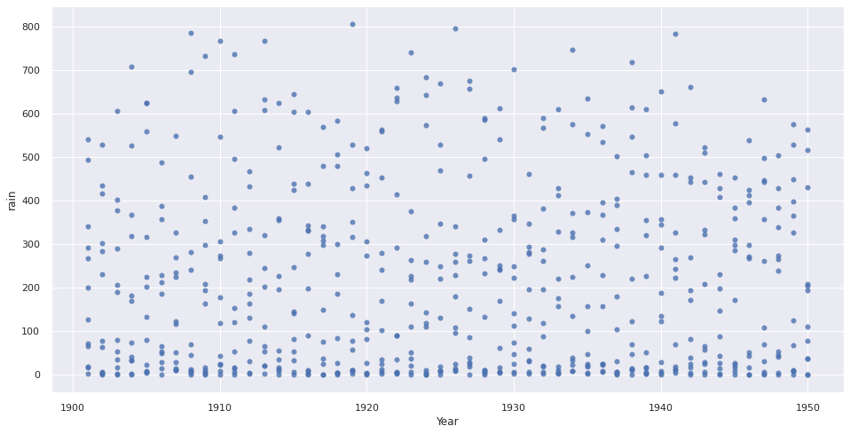

Step xi-

Plotting data as a figure using ploty library.

pio.templates.default = "plotly_dark"

fig = px.line(df1,x='Year',y='rain',color="Year",title="Measurement of Rain according to Year")

fig.show()

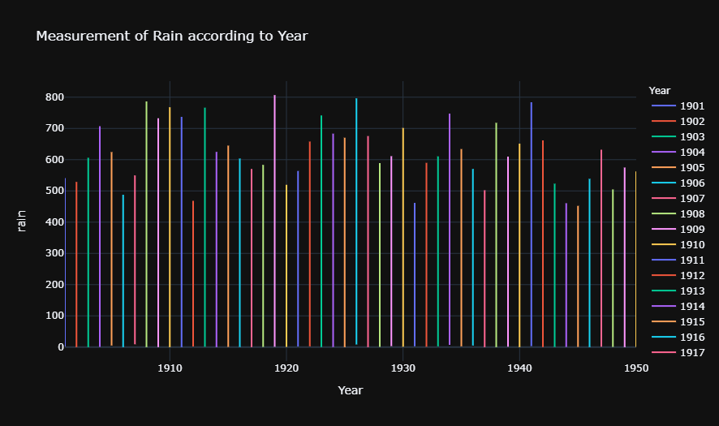

**Step xii-**

Fetching maximum value of rain.

df1.rain.max()

**Step xiii-**

We can see that year between 1901 to 1950 , 1919 has the maximum amount of rain Let's see relation between Month & Rain

pio.templates.default = "plotly_dark"

fig = px.line(df1,x='Month',y='rain',color="Year",title="Measurement of Rain according to Month")

fig.show()

**Step xiv-**

Plotting data as a bar chart and visualizing it.

pio.templates.default = "plotly_dark"

fig = px.bar(df1[0:100],x='Month',y='rain',color="Year",title="Measurement of Rain according to Month")

fig.show()

